Classification of polymers

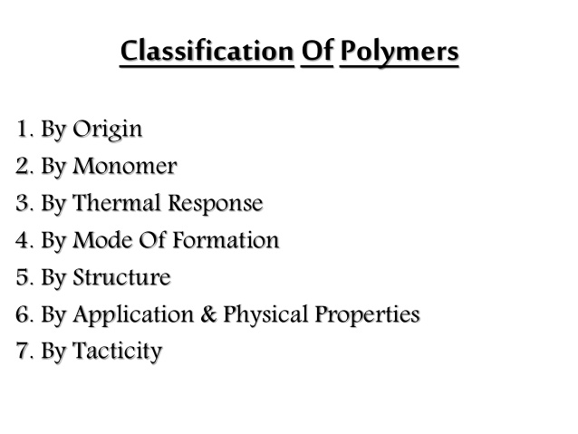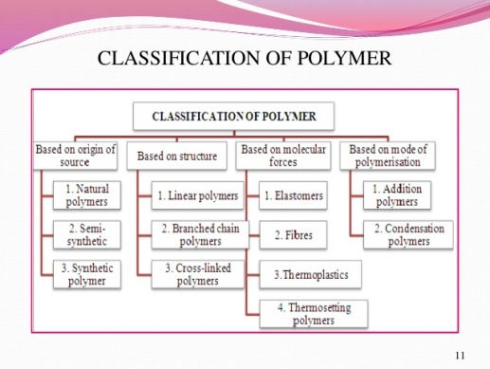
- Based on origin:
Polymers are of two types: naturally occurring and synthetic or man made.
Natural polymeric materials such as hemp, shellac, amber, wool, silk, and natural rubber have been used for centuries. A variety of other natural polymers exist, such as cellulose, which is the main constituent of wood and paper.
The list of synthetic polymers, roughly in order of worldwide demand, includes polyethylene, polypropylene, polystyrene, polyvinyl chloride, synthetic rubber, phenol formaldehyde resin (or Bakelite), neoprene, nylon, polyacrylonitrile, PVB, silicone, and many more. More than 330 million tons of these polymers are made every year (2015)
- Based on monomer:
The identity of the repeat units (monomer residues, also known as "mers") comprising a polymer is its first and most important attribute. Polymer nomenclature is generally based upon the type of monomer residues comprising the polymer. A polymer which contains only a single type of repeat unit is known as a homopolymer, while a polymer containing two or more types of repeat units is known as a copolymer.^{[26]} A terpolymer is a copolymer which contains three types of repeat units.^{[27]}
Polystyrene is composed only of styrene-based repeat units, and is classified as a homopolymer. Polyethylene terephthalate, even though produced from two different monomers (ethylene glycol and terephthalic acid), is usually regarded as a homopolymer because only one type of repeat unit is formed. Ethylene-vinyl acetate contains more than one variety of repeat unit and is a copolymer. Some biological polymers are composed of a variety of different but structurally related monomer residues; for example, polynucleotides such as DNA are composed of four types of nucleotide subunits.
Homopolymers and copolymers (examples)
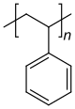 | 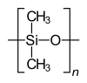 | 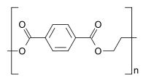 | 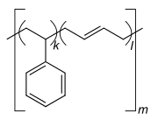
Homopolymer polystyrene | Homopolymer polydimethylsiloxane, a silicone. The main chain is formed of silicon and oxygen atoms. | The homopolymer polyethylene terephthalate has only one repeat unit. | Copolymer styrene-butadiene rubber: The repeat units based on styrene and 1,3-butadiene form two repeating units, which can alternate in any order in the macromolecule, making the polymer thus a random copolymer.
A polymer molecule containing ionizable subunits is known as a polyelectrolyte or ionomer.
3. Based on thermal response:
Thermoplastic: Those polymers which soften on heating and moulded or extruded in to required shapes are known as plastics for the manufacturing of a wide range of articles. E.g. Polyethylene, polypropelene, P.V.C, polystyrene, etc.
The process of heating, reshaping and retaining the same on cooling can be repeated several times.
Thermosetting Polymers: A sample of such material is gigantic molecule and heating does not soften it, since softening would require breaking of covalent bond. Indeed, heating may causes formation of additional cross-links and make the material harder, for this reason space network polymer are called thermosetting polymer. Such polymers, upon heating sets into an infusible mass and once sets cannot be reshaped. E.g. Phenol-formaldehyde (Bakelite), Urea-formaldehyde (polyurethane) etc.
- Based on synthesis:
Polymers are formed in two general ways:
(A) Addition polymerization (Chain reaction polymerization)
(B) Condensation polymerization (Step reaction polymerization)
(A) Addition Polymerization: There is series of reactions each of which consumes a reactive particle and produce another similar particle, each individual reaction thus depends upon the previous one. The reactive particles can be free radicals; cation or anion
CH₂=CH₂ + Rad. ___________ Rad –CH₂-CH₂.
Rad –CH₂-CH₂. + n( CH₂=CH₂) __________ [___CH₂ ___CH₂ __]- _{n}
Polyethylene
(B) Condensation Polymerization: There is a series of reactions each of which is essentially independent of the preceding one. Formation of polymer takes place because the monomer undergoes reaction at more than one functional group. E.g. A diol reacts with a dicarboxylic acid to form an ester but each moiety of the simple ester still contain a group that can react to generate another ester linkage and hence a large molecule and so on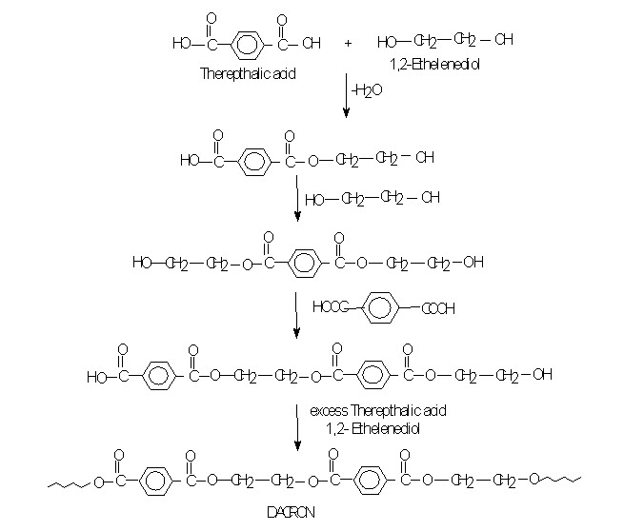
- Based on structure:
The microstructure of a polymer (sometimes called configuration) relates to the physical arrangement of monomer residues along the backbone of the chain.^{[28]} These are the elements of polymer structure that require the breaking of a covalent bond in order to change. Various polymer structures can be produced depending on the monomers and reaction conditions: A polymer may consist of linear macromolecules containing each only one unbranched chain. In the case of unbranched polyethylene, this chain is a long-chain n-alkane. There are also branched macromolecules with a main chain and side chains, in the case of polyethylene the side chains would be alkyl groups. In particular unbranched macromolecules can be in the solid state semi-crystalline, crystalline chain sections highlighted red in the figure below.
While branched and unbranched polymers are usually thermoplastics, many elastomers have a wide-meshed cross-linking between the "main chains". Close-meshed crosslinking, on the other hand, leads to thermosets. Cross-links and branches are shown as red dots in the figures. Highly branched polymers are amorphous and the molecules in the solid interact randomly.
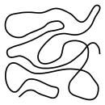  linear, unbranched macromolecule | 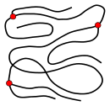  branched macromolecule | 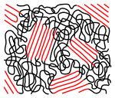  semi-crystalline structure of an unbranched polymer | 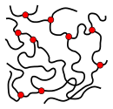  slightly cross-linked polymer (elastomer) | 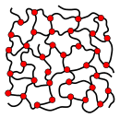  highly cross-linked polymer (thermoset)

Based on Monomer arrangement in copolymers
Copolymers are classified either as statistical copolymers, alternating copolymers, block copolymers, graft copolymers or gradient copolymers. In the schematic figure below, Ⓐ and Ⓑ symbolize the two repeat units.
random copolymer | gradient copolymer | 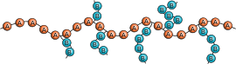  graft copolymer
alternating copolymer | block copolymer
- Alternating copolymers possess two regularly alternating monomer residues:^{[42]} [AB]_{n}. An example is the equimolar copolymer of styrene and maleic anhydride formed by free-radical chain-growth polymerization.^{[43]} A step-growth copolymer such as Nylon 66 can also be considered a strictly alternating copolymer of diamine and diacid residues, but is often described as a homopolymer with the dimeric residue of one amine and one acid as a repeat unit.^{[44]}
- Periodic copolymers have more than two species of monomer units in a regular sequence.^{[45]}
- Statistical copolymers have monomer residues arranged according to a statistical rule. A statistical copolymer in which the probability of finding a particular type of monomer residue at a particular point in the chain is independent of the types of surrounding monomer residue may be referred to as a truly random copolymer.^{[46][47]} For example, the chain-growth copolymer of vinyl chloride and vinyl acetate is random.^{[43]}
- Block copolymers have long sequences of different monomer units.^{[43][44]} Polymers with two or three blocks of two distinct chemical species (e.g., A and B) are called diblock copolymers and triblock copolymers, respectively. Polymers with three blocks, each of a different chemical species (e.g., A, B, and C) are termed triblock terpolymers.
- Graft or grafted copolymers contain side chains or branches whose repeat units have a different composition or configuration than the main chain.^{[44]} The branches are added on to a preformed main chain macromolecule.^{[43]}
Monomers within a copolymer may be organized along the backbone in a variety of ways. A copolymer containing a controlled arrangement of monomers is called a sequence-controlled polymer.^{[48]} Alternating, periodic and block copolymers are simple examples of sequence-controlled polymers.

Based on Tacticity
Tacticity describes the relative stereochemistry of chiral centers in neighboring structural units within a macromolecule. There are three types of tacticity: isotactic (all substituents on the same side), atactic (random placement of substituents), and syndiotactic (alternating placement of substituents).
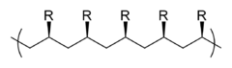  isotactic | 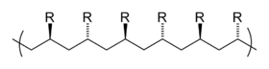  syndiotactic | 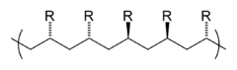  atactic (i. e. random)

- Based on molecular force:
A large number of polymer applications in different fields depend on their unique mechanical properties like tensile strength, elasticity, toughness, etc. These mechanical properties are governed by intermolecular forces, e.g., van der Waals forces and hydrogen bonds, present in the polymer. These forces also bind the polymer chains. Under this category, the polymers are classified into the following four sub groups on the basis of magnitude of intermolecular forces present in them.
- Elastomers
These are rubber – like solids with elastic properties. In these elastomeric polymers, the polymer chains are held together by the weakest intermolecular forces. These weak binding forces permit the polymer to be stretched. A few ‘crosslinks’ are introduced in between the chains, which help the polymer to retract to its original position after the force is released as in vulcanised rubber. The examples are buna-S, buna-N, neoprene, etc.
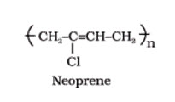
- Fibres
Fibres are the thread forming solids which possess high tensile strength and high modulus. These characteristics can be attributed to the strong intermolecular forces like hydrogen bonding. These strong forces also lead to close packing of chains and thus impart crystalline nature. The examples are polyamides (nylon 6, 6), polyesters (terylene), polyacrylonitrile etc.
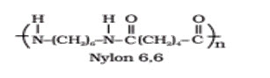
- Thermoplastic polymers
These are the linear or slightly branched long chain molecules capable of repeatedly softening on heating and hardening on cooling. These polymers possess intermolecular forces of attraction intermediate between elastomers and fibres. Some common thermoplastics are polythene, polystyrene, polyvinyls, etc.
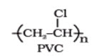
- Thermosetting polymers
These polymers are cross linked or heavily branched molecules, which on heating undergo extensive cross linking in moulds and again become infusible. These cannot be reused. Some common examples are bakelite, urea-formaldelyde resins, etc.
